Exercise 07 Multi Record Query

1. **Initial Setup – Follow this first step OR start from scratch like in Exercise 06, your choice** 
   1. Fork the repo called “WebAppNW02-MultiRecord” from “RobbinLawCPSC1517/” to your github account.
   2. Clone the newly forked repo from your account into Visual Studio.
   3. Restore the packages, and then restart the Visual Studio IDE.
   4. Change the name of the solution from “WebAppNW02-MultiRecord” to “WebAppEx06”.
   5. Run the code to make sure it works before making changes as per Exercise 06. When it works commit and push back to your github repo.
2. **Entity Replacement or Creation**
   1. Replace the Entities that are already in place as described below. Remember to look at the actual database data types and reflect them properly in the Entity definitions. Also remember that when you define something with say “int?”, this means that the database field in the actual database is NULLABLE. Strings don’t need this and of course the primary key as it will never be null.
   2. In the Entities01.cs class file change the Categories definition of the Northwind database to the Teams definition of the FSIS database.
   3. In the Entities02.cs class file change the Products definition of the Northwind database to the Players definition of the FSIS database.
   4. In the Entities03.cs class file change the Suppliers definition of the Northwind database to the Guardians definition of the FSIS database.
3. **DAL Context Replacement or Creation**
   1. Change the name of the database from “NWDB” to “FSIS_db” in the Context.cs file.
4. **BLL Controller Replacement or Creation**
   1. Change Controller02.cs to reflect the changes from the Northwind database to the FSIS database. This means calling the right Stored Procedure. Replace the stored procedure called “Products_GetByCategories” with “Player_GetByTeam”.
5. **PL Form Replacement or Creation**
   1. In the ExcercisePages/MultiRecordQueryWithCustomGridView Form change the tags as appropriate. This means renaming to reflect the Team and Player Tables of the FSIS Database instead of the Categories and Products Tables of the Northwind Database.
   2. In the MultiRecordQueryWithCustomGridView code behind add/change the code necessary to make everything work when the button is pressed.
   3. The running code should look similar to the screen shot below. This exercise should be easy if you use my Northwind code as a template. As I said though, if you want a challenge, try doing this exercise from scratch, like Exercise 05.
   4. Test your code and when it works, save it to GitHub.

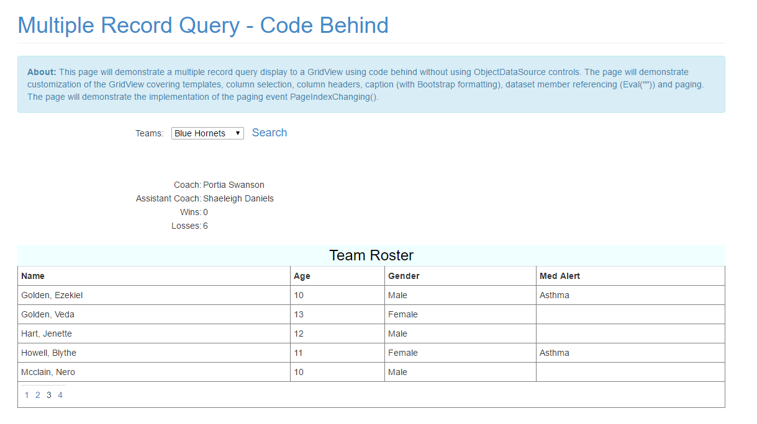

A team with no players should have a EmptyTemplate message shown.

